Black Cat
Bat
Pumpkin
Ghost
Skeleton
Spider
Witch
Mummy
 | 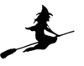 | 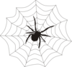 | 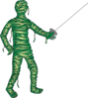
 | 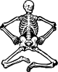 | 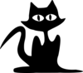
Halloween Copy and Paste Pictures
Name:

